“Stick it to stigma”

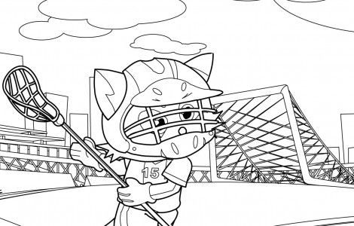
We’ve got your back

